Manuscript Title
Author 1 ª*, Author 2 ^{b}, Author 3 ^{c}, Author 4 ^{d} and Author 5 ^{e}

a | Affiliation – Author 1 (*corresponding author)
b | Affiliation – Author 2
c | Affiliation – Author 3
d | Affiliation – Author 4
e | Affiliation – Author 5

Abstract:
This document provides a template that can be used for the paper submission. This template includes several examples for the section set-ups, figures, tables, citations, and references. Please feel free to add and/or change them accordingly. Also, a detailed guideline for the paper submission can be found on the 14th NAMC webpage.

Keywords: 14th NAMC, Manuscript, Template, Guidelines

Introduction
This is an example text for demonstration purposes. Please insert your actual text right here. This is an example text for demonstration purposes. Please insert your actual text right here. This is an example text for demonstration purposes. Please insert your actual text right here. This is an example text for demonstration purposes. Please insert your actual text right here. This is an example text for demonstration purposes. Please insert your actual text right here.

A Subsection
This is an example text for demonstration purposes. Please insert your actual text right here. This is an example text for demonstration purposes. Please insert your actual text right here.

Background
This is an example text for demonstration purposes. Please insert your actual text right here. This is an example text for demonstration purposes. Please insert your actual text right here. This is an example text for demonstration purposes. Please insert your actual text right here. This is an example text for demonstration purposes. Please insert your actual text right here. This is an example text for demonstration purposes. Please insert your actual text right here.

A Subsection
This is an example text for demonstration purposes. Please insert your actual text right here. This is an example text for demonstration purposes. Please insert your actual text right here.

Another Subsection
This is an example text for demonstration purposes. Please insert your actual text right here. This is an example text for demonstration purposes. Please insert your actual text right here.

Methodology
This is an example text for demonstration purposes. Please insert your actual text right here. This is an example text for demonstration purposes. Please insert your actual text right here. This is an example text for demonstration purposes. Please insert your actual text right here. This is an example text for demonstration purposes. Please insert your actual text right here. This is an example text for demonstration purposes. Please insert your actual text right here.

A Subsection
This is an example text for demonstration purposes. Please insert your actual text right here. This is an example text for demonstration purposes. Please insert your actual text right here.
An example for an equation is:
$V_{nm}=\left(4-1.75\frac{M_{u}}{V_{u}d_{v}}\right)A_{nv}\sqrt{f_{m}^{'}}$ (1)
where $\frac{M_{u}}{V_{u}d_{v}}$ is the shear span ratio, $A_{nv}$ is the net shear area (in²), and $f_{m}^{'}$ is the compressive strength of the masonry (psi).

Another Subsection
This is an example text for demonstration purposes. Please insert your actual text right here. This is an example text for demonstration purposes. Please insert your actual text right here.
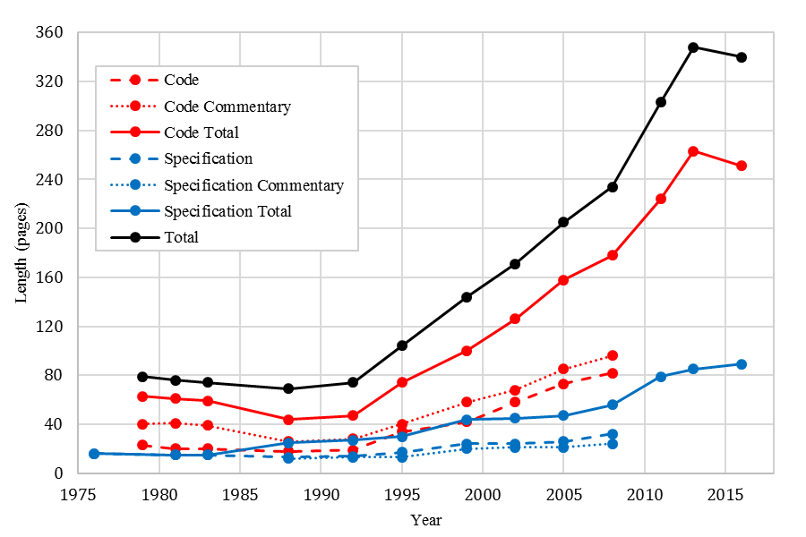
Figure 1. An Example of a Figure

A Sub-Subsection
This is an example text for demonstration purposes. Please insert your actual text right here.

Table 1. An Example of a Table
Font Style Name | Typeface | Size (pt) | Shape | Alignment | Line Spacing | Spacing (pt) | Indent (in.)
Body text
Heading 1 | Times New Roman | 13 | Bold, small caps | Left | Single | Before: 18  After: 4 | —
Heading 2 | Times New Roman | 12 | Bold | Left | Single | After: 3 | —
Heading 3 | Times New Roman | 11 | Bold, italic | Left | Single | After: 2 | —
Body text | Times New Roman | 11 | — | Justified | 1.15 | After: 10 | —
List paragraph | Times New Roman | 11 | — | Left | 1.15 | After: 10 | —
Table text | Times New Roman | 10 | — | Varies | Single | — | —
Equations | Cambria Math | 11 | — | Centered | Single | After: 10 | 0.5
Specialty text
Caption label and number | Times New Roman | 10 | Bold | Centered | Single | — | —
Caption text | Times New Roman | 10 | — | Centered | Single | — | —
Equation numbers | Times New Roman | 11 | Bold | Right | Single | After: 10 | —
Table footnotes | Times New Roman | 8 | — | Left | Single | After: 3 | —
The font style can be quickly selected by clicking the respective style name in the Styles toolbar on the MS Word ribbon. To prevent formatting errors in the document, the built-in styles in this template should not be modified.
This is an example text for demonstration purposes. Please insert your actual text right here. This is an example text for demonstration purposes. Please insert your actual text right here. This is an example text for demonstration purposes. Please insert your actual text right here. This is an example text for demonstration purposes.
Table 2. Examples of Textual and Parenthetical Citations
 | Textual citation | Parenthetical citation
One author | Jaffe (2017)… | (Jaffe 2017)
Two authors | Eisenhauer and Klinger (2017)… | (Eisenhauer and Klinger 2017)
Three or more authors | Redmond et al. (2016)… | (Redmond et al. 2016)
Multiple citations | Kim and Bennett (2002) and Liu et al. (2006)… | (Kim and Bennett 2002, Liu et al. 2006)

Conclusions
This is an example text for demonstration purposes. Please insert your actual text right here. This is an example text for demonstration purposes. Please insert your actual text right here. This is an example text for demonstration purposes. Please insert your actual text right here. This is an example text for demonstration purposes. Please insert your actual text right here. This is an example text for demonstration purposes. Please insert your actual text right here.
- This is an example text for demonstration purposes.
- This is an example text for demonstration purposes.
- This is an example text for demonstration purposes.

Acknowledgments
This is an example text for demonstration purposes. Please insert your actual text right here. This is an example text for demonstration purposes. Please insert your actual text right here. This is an example text for demonstration purposes.

References
Jaffe, R. C. (2017). Masonry Basics, 2nd Ed., The Masonry Society (TMS), Longmont, CO.
Eisenhauer, J. T. and Klinger, R. E. (2017). Masonry Structural Design, 2nd Ed., The Masonry Society (TMS), Longmont, CO.
Redmond, L., Kahn, L., and DesRoches, R. (2016). “Shear and tensile strength equations for analysis of grouted masonry,” TMS Journal, 34(1), 29-38.
Kim, S. K. and Bennett, R. M. (2002). “Flexural tension in unreinforced masonry: evaluation of current specifications,” TMS Journal, 20(1), 23-30.
Liu, L., Tang, D., and Zhai, X. (2006). “Failure criteria for grouted concrete block masonry under biaxial compression,” Advances in Structural Engineering, 9(2), 229-239.

